

Elastic Map Reduce

Amazon EMR

- Amazon EMR is a service which deploys out EC2 instances based off of the Hadoop big data software. EMR is used to analyze and process vast amounts of data.

- The data which is mapped to a cluster of Hadoop Master/Slave nodes for processing, allows for computations to be performed by the servers (computations coded/created by the developer) and reduces to a single output set of return information

- EMR can run any OpenSource application built on Hadoop

Amazon EMR

- EMR launches EC2 instances for processing the data passed to Hadoop

- Gives the admin ability to access the underlying operating system

- Integrates in with AWS services s uch as S3, DynamoDB, RedShift (Petabyte Scale Data Warehouse) to receive and output data

- Bootstrapper enables the ability to pass configuration information before Hadoop s tarts when a new cluster is created

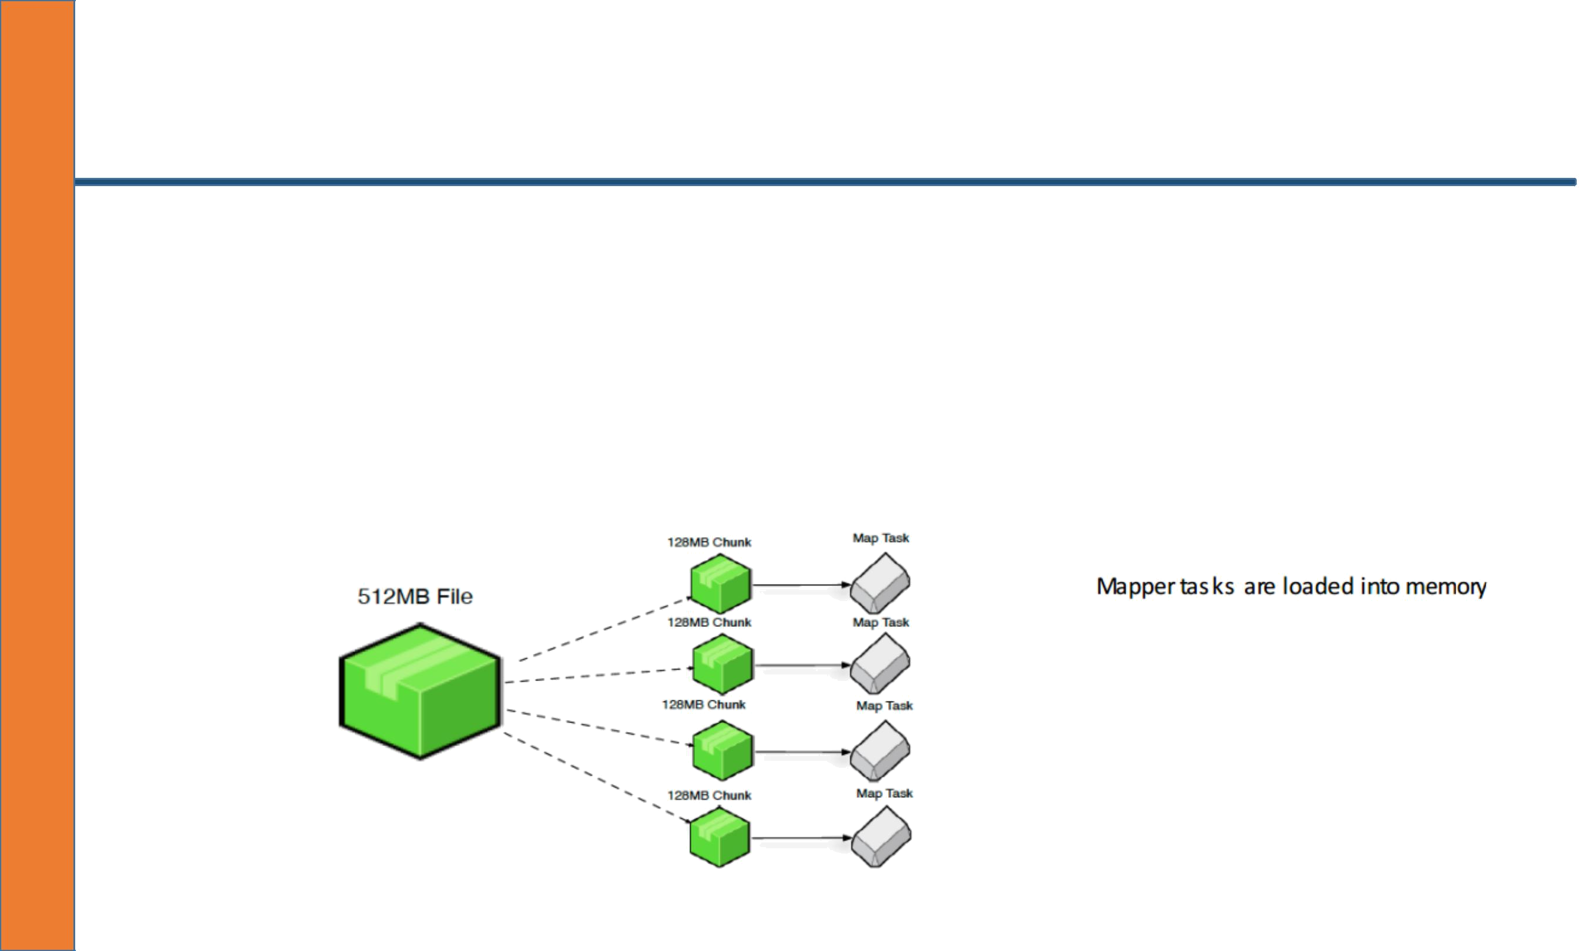
Amazon EMR

- Mappers are essentially the processes that split the large data file for processing Reducers takes the result (if there is ) and combines it back into a data file on the disk

- Word counter:

- Mapper: The text being processed looking for the key word

- Reducer: The outputted number result found (5 results for the word being searched for) and combined back into the single result data file

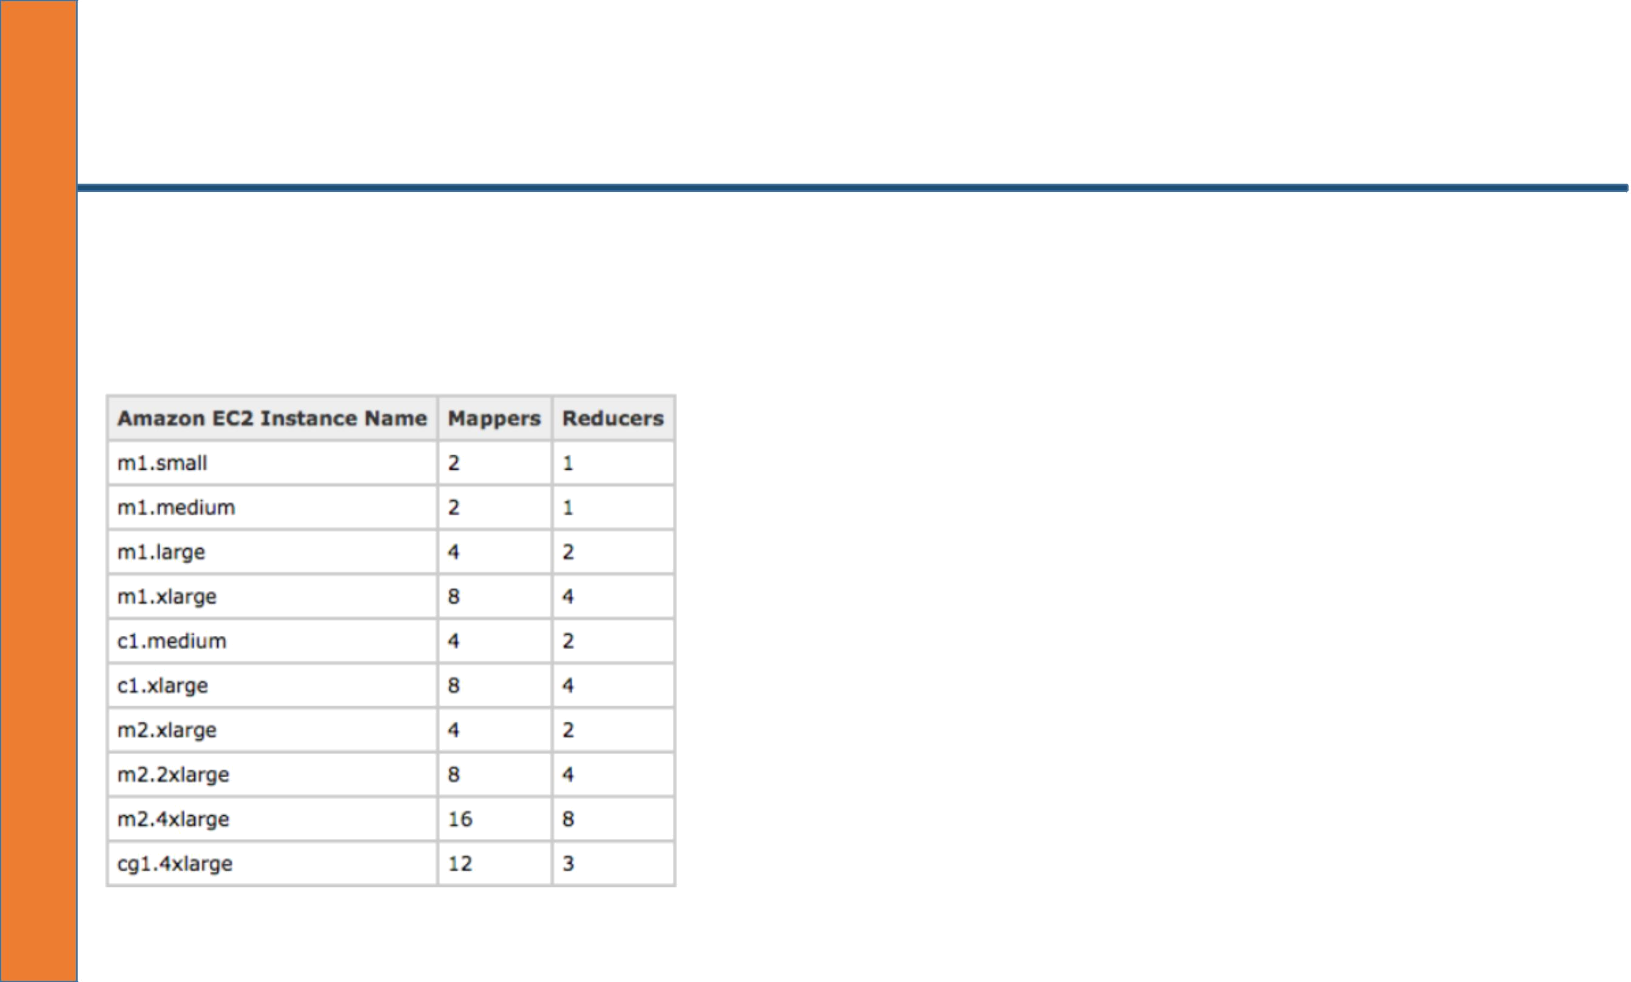
Amazon EMR Instanses

AWS EMR has already pre-configured the Hadoop AMI to have the best possible performance based off of instance size

- A single mapper is configured by AWS to handle
128MB “split” files (this is the default on certain versions of Amazon AMI Hadoop and can be changed)

- To Increase performance you can adjust the “split” size of the file note that changing the split size might require more mappers to be started

- Split files are loaded into memory for processing

- If there are 5128MB split files waiting for mapping then AWS will queue the ones not being processed increasing the amount of time for a single job to complete

- Cluster can launch multiple instances for parallel processing reducing the amount of time a job takes to complete by processing multiple split files with the mapper at one time

- Goal is to use as many mappers as you can without running out of memory for loading of data

- If your job is queuing up it can increase job run time here are some considerations:

- Determine if you have unused mappers, if you have unused mappers then consider changing the input split size

- If you do not have unused mappers s peed up the process by adding more mappers (adding more core/ task nodes to the cluster)

- Both of these methods would be considered as increasing the number of available mappers

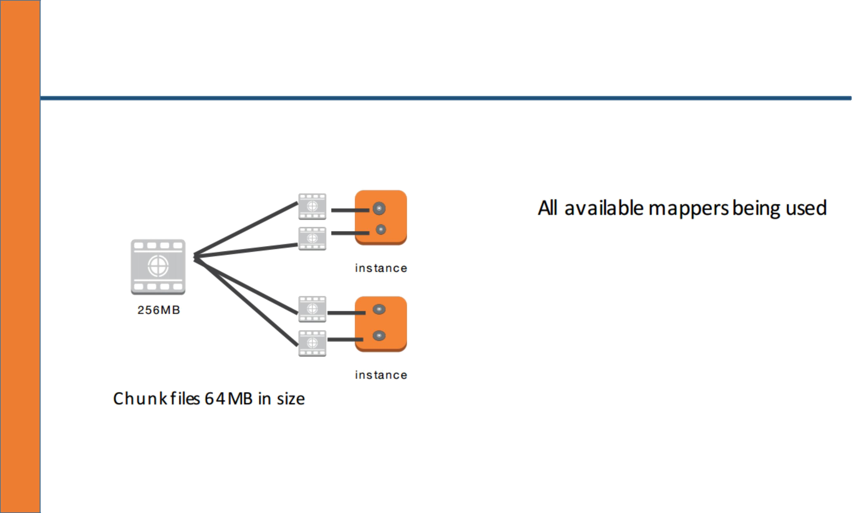



Amazon EMR Cluster Architecture

Workflow:

- Load the data into the cluster (Can come from S3) also can load S3 as a local file sys tem (increases performance and decreases job loading time)

- Analyze the data (done by programming/scripts )

- Store the results in the Hadoop Distributed File System (HDFS) or S3 (Faster/persistent)

- Read the results from the cluster HDFS

Master Node: Only provides information about the data (where it is coming from) and where it should
go Core Node: Processes the data and stores it on HDFS or S3 Task Node: Processes the data and sends back to the Core node for storage on the HDFS or S3

The HDFS stores the “reduced” result on the local file sys tem which means the data is only persistent for as long as the cluster is running. Once terminated the data is lost

Storing the “reduced” data on S3 helps create persistent storage and reduces the amount of time it
takes to copy the data from the HDFS storage disks to the original location (S3).

Amazon EMR Cluster Architecture

- Bootstrap Action: Can be used to install additional software or change configurations before Hadoop starts on a new EMR cluster

- Performance increases when running S3 as a local file system as it directly connects to S3 and enables multi-part uploading for faster uploading processing of data to and f rom S3. By default the S3 file system is already installed on all nodes in a cluster

- Bootstrap action can be used to enable multi-part upload

- Using S3 for the primary file system with multi-part upload enabled decreases the job run time and provides persistence for your cluster

- S3 increases durability of reduced data

